Lab 3
Q1
Source code
class search:
def bsearch(self, searchval):
for x in range(2):
if(searchval==arr[x]):
return x

arr = ["nabeel","rizwan", "Quadri"]
searchval = input("Enter value to be searched: ")

nabeel = search()
b = nabeel.bsearch(searchval)
print("The value was found at: ",b)

Output
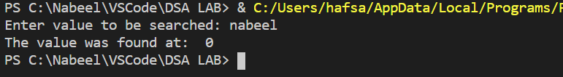

Q2
Source code
def binarySearch (arr, l, r, x):
if r >= l:

mid = l + (r - l) // 2

if arr[mid] == x:
return mid

elif arr[mid] > x:
return binarySearch(arr, l, mid-1, x)

else:
return binarySearch(arr, mid + 1, r, x)

else:
return -1

arr = [ 1, 2, 3, 4, 10, 40, 60, 90, 100, 101]
x = 3

result = binarySearch(arr, 0, len(arr)-1, x)

if result != -1:
print ("Element is present at index % d" % result)
else:
print ("Element is not present in array")

arr = [ 1, 2, 3, 4, 10, 40, 60, 90, 100, 101]
x = 4

result = binarySearch(arr, 0, len(arr)-1, x)

if result != -1:
print ("Element is present at index % d" % result)
else:
print ("Element is not present in array")

arr = [ 1, 2, 3, 4, 10, 40, 60, 90, 100, 101]
x = 5

result = binarySearch(arr, 0, len(arr)-1, x)

if result != -1:
print ("Element is present at index % d" % result)
else:
print ("Element is not present in array")

Output
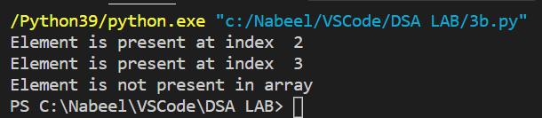

Q3
Source code
def binary_search(item_list,item):
first = 0
last = len(item_list)-1
found = False
while( first<=last and not found):
mid = (first + last)//2
if item_list[mid] == item :
found = item
else:
if item < item_list[mid]:
last = mid - 1
else:
first = mid + 1
return found

arr = [10,26,33,52,86]
x = 52
y = 33
print(binary_search(arr, x))
print(binary_search(arr, y))

Output
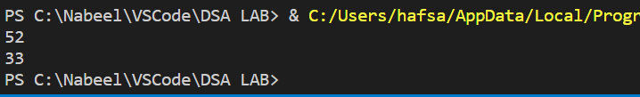

Q4
Source code
def binarySearch(alist, item):
first = 0
last = len(alist)-1
found = False

while first<=last and not found:
midpoint = (first + last)//2
if alist[midpoint] == item:
found = True
alist.pop(midpoint)

else:
if item < alist[midpoint]:
last = midpoint-1
else:
first = midpoint+1

return found

NUMBERS = [11,22,33,36,45,52,57,60,64,78]

print("the old list is:")
for x in range(len(NUMBERS)):
print(NUMBERS[x])

x = 45
y = 78
print("The number was: ", binarySearch(NUMBERS, x))
print("The number was: ", binarySearch(NUMBERS, y))

print("The new list is: ")
for x in range(len(NUMBERS)):
print(NUMBERS[x])

Output
